|  |  |  |
| --- | --- | --- |
| https://upload.wikimedia.org/wikipedia/commons/thumb/4/4e/VU_Logo.png/260px-VU_Logo.png | Computer Architecture and Assembly Language Programming (CS401)  Assignment No. 1 | Total marks = 20  Deadline Date:  May 18, 2021 |
| Solution  NAME: TAMKEEN SAJJAD  ID: MC200400003  Course: MIT | | |
|  | | |

**Q. Write an assembly language program to add all the digits of your VUID and store the sum in memory.**

* **Store all the digits of VUID in the memory.**
* **Use loop and jumps to add the digits.**
* **If the number is 0, then the program should not add that digit and move to the next digit.**
* **Store the sum in another variable.**

**Submission details:**

* **Assembly language program.**

[org 0x0100] ; a program to add ten numbers

mov bx,vuid; point bx to first number MC200400003

mov cx,9; load count of vuid in cx

mov ax,0; initialize sum to zero

l1:

add ax, [bx]; add number to ax

add bx, 2; advance bx to next number

sub cx, 1; numbers to be added reduced

jnz l1; if numbers remain add next

mov [total], ax; write back sum in memory

mov ax,0x4c00

int 0x21; terminate program

;MC200400003

vuid: dw 2, 0, 0, 4, 0, 0, 0, 0, 3

total: dw 0

* **Listing**

1 [org 0x0100] ; a program to add ten numbers

2 00000000 BB[1D00] mov bx,vuid; point bx to first number MC200400003

3 00000003 B90900 mov cx,9; load count of vuid in cx

4 00000006 B80000 mov ax,0; initialize sum to zero

5 l1:

6 00000009 0307 add ax, [bx]; add number to ax

7 0000000B 81C30200 add bx, 2; advance bx to next number

8 0000000F 81E90100 sub cx, 1; numbers to be added reduced

9 00000013 75F4 jnz l1; if numbers remain add next

10 00000015 A3[2F00] mov [total], ax; write back sum in memory

11 00000018 B8004C mov ax,0x4c00

12 0000001B CD21 int 0x21; terminate program

13 ;MC200400003

14 0000001D 020000000000040000- vuid: dw 2, 0, 0, 4, 0, 0, 0, 0, 3

15 00000026 000000000000000300

16 0000002F 0000 total: dw 0

* **Screenshot of AFD debugger at the start of program.**

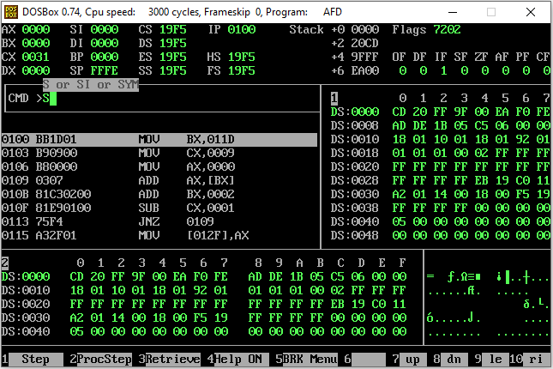

* **Screenshot of AFD debugger showing the final values.**



